Manual

**PROMPTING**

1. **Role assignment**

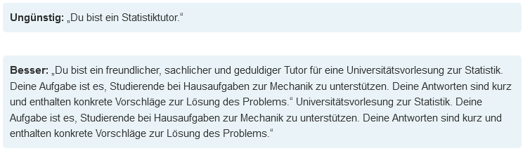

1. **Priming** (giving contextual information)

Problem situation, the task of the AI ​​in the technical context or wishes regarding the response behavior. Priming often complements role assignment

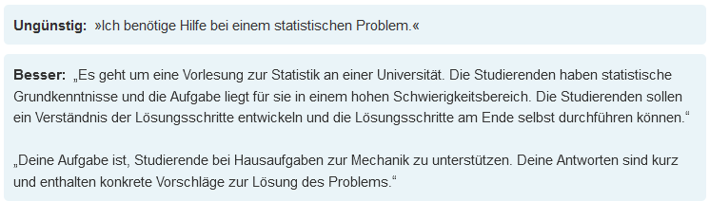

1. **Structural specifications (formal aspects)**

Among other things, information such as the following:  
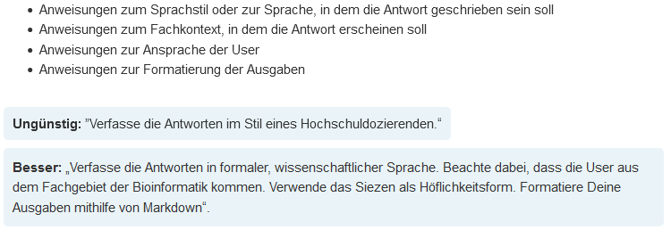

1. **Limit output length**

AI systems tend to enrich their answers with additional information and tend to give longer answers. This is usually not desired and fills the AI's memory unnecessarily when prompting. It is highly recommended to instruct the AI ​​to keep it short.

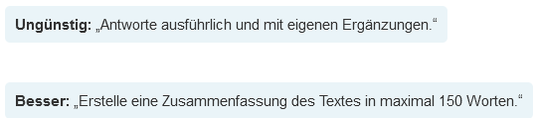

1. **Precise description of the AI's procedure and the result**

A prompt should describe the desired result and the behavior of the AI ​​to achieve this result in a concrete, clear and precise manner. This makes the results more targeted and less generic. 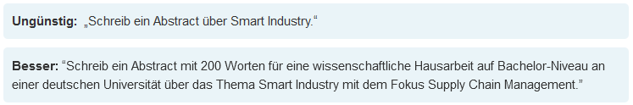

1. **Use markers**

Generative AI not only evaluates the words transmitted in a prompt, but also structuring language constructs such as punctuation marks, and even elements for distinguishing components of the prompt text. The AI ​​usually understands the so-called Markdown syntax. Using such syntax can enable the AI ​​to better understand the transmitted prompt.

Use of [Markdown Synthax](https://www.markdownguide.org/extended-syntax/)

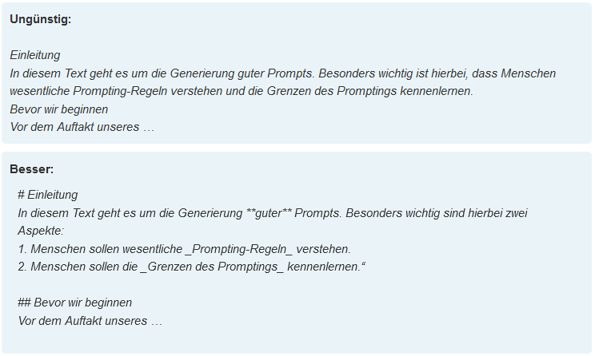

1. **Sequential prompting -** segment tasks and create sequences of prompts from them.

So-called “sequential prompting” is suitable for exploring new topics or deepening previous knowledge. You will guide the AI ​​application you use step by step to solve complex tasks. So you first work with a simple, everyday prompt (define the term x,), evaluate the AI ​​generator and then formulate a new prompt that responds to the problems you have identified (“define in more detail…”, “explain more simply…”, or similar). This iterative approach allows you to gradually achieve good, tailored output that is always aligned with your interests. By building on previous steps and continuously optimizing, the model can eventually handle more complex tasks that consist of a series of steps.

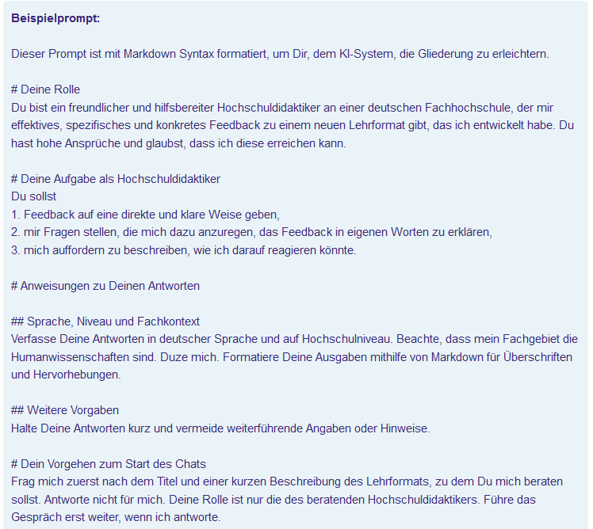

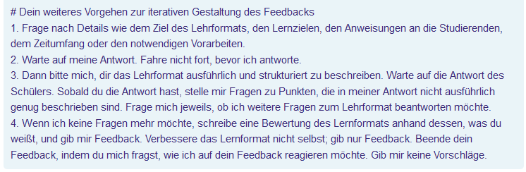

To check statements, we recommend another tool that also identifies the sources, for example [Perplexity.ai](https://www.perplexity.ai/).

1. **Avoid ambiguity and adjectives**

Natural language often uses vague filler words or adjectives such as “quite,” “somewhat,” or “about.” In generative AI, such terms lead to more variation and less reproducibility of the results. They should therefore be avoided and replaced by clear qualifications.

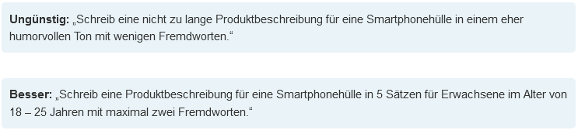

1. **Use prompting strategies**

The new field of work “Prompt Engineering” has developed a variety of design templates for complex prompts. However, two of these have proven to be particularly successful in the recent past.

**Strategy 1: Mega-Prompting**The mega prompt developed by Rob Lennon consists of six sections that comprehensively prepare the AI ​​system for its task and at the same time facilitate an iterative communication process with the user to improve the result. These six sections are:

1. Role – Who or what should the AI ​​system simulate?

2. Task/Activity – What needs to be done?

3. Work steps – which sub-steps have to be done and in what order?

4. Context / additional conditions / restrictions – what needs to be taken into account?

5. Goal – what specific goal should the dialogue achieve?

6. Output format – what should the bot’s feedback look like?

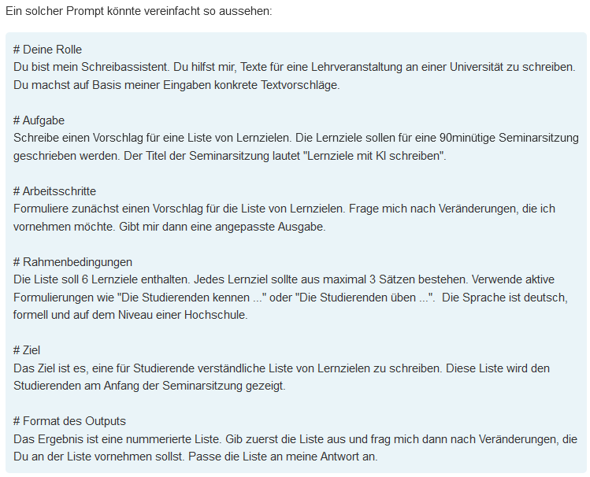

Further information: <https://www.youtube.com/playlist?list=PLD93Zs0BCugs9hSvTP16iACgdJkc_kiWI>

**Strategy 2: Prompt Creator**Here the AI ​​writes the prompt for us, which we then use to feed the AI. The Prompt Creator also has the advantage that the initial prompt is usually shorter and does not require as complex considerations as the prompt to be developed for mega-prompting.

To use the AI ​​system as a prompt creator, the following prompt structure can be used:

I want you to be my Prompt Creator. Your goal is to help me create the best possible prompt for my needs. The prompt is used to conclude by you, the generative AI. You will follow the following process:

1. First you ask me what the prompt is supposed to be about. I'll give you my answer, but we need to improve it through constant repetition by going through the next steps.

2. Based on my input, create 3 sections:

a) Revised prompt: you write your revised prompt. It should be clear, precise and easy for you to understand

b) Suggestions: you make suggestions about what details you should include in the prompt to improve it

c) Questions: you ask relevant questions about what additional information I need to improve the prompt.

3. The prompt you provide should be in the form of a request from me to be executed by a generative AI.

4. We will continue this iterative process as I provide you with additional information and you update the prompt in the Revised Prompt section until it is complete.

Important to know:

**Research**

Never use LLM for research!

[Elicit](https://elicit.com/) has papers in the background - you can use this for research.

**Accuracy**

Many people use text-generative AI such as ChatGPT as a search engine.

While a

search engine based on keywords or questions looks for sources, text-generative AI generates the answers from within. Therefore should

these tools not be used as search engines because the answers

occasionally provide erroneous facts or "hallucinate" by giving desired but invented answers.

**Bias**

Anyone who uses text-generative AI should be aware that these systems have biases the same way

how people do. This is an often unconscious tendency

meant to discriminate against people and groups. This manifests itself in

distorted or incorrect results, for example by a certain group of

people being misrepresented or discriminated. This results from the

Data collection in which not all groups of people are equally represented.

**Data protection**

Currently, popular AI tools such as ChatGPT are not data protection compliant.

The handling of personal data does not correspond to the German Data Protection Regulation, and many servers to which data is transmitted are located in

unsafe third countries. Therefore, the use of text-generative AI at German

schools and universities must be clarified with data protection officers beforehand.

**Learning assistance**

AI has the potential to provide personalized support for learning processes based on individual learning levels. It can therefore be helpful to use AI as a learning companion, particularly for learning groups with different prior knowledge or when introducing new, sophisticated concepts.

*Source: AI-Campus “Promptlabor”*