**Quick checklist**

* Internetconnection – avoid large images (200kb max) videofiles
* Devices – Accessibility and readability on mobile phones
* Colours and contrast <https://webaim.org/resources/contrastchecker/>
* Fontsize – not too small
* 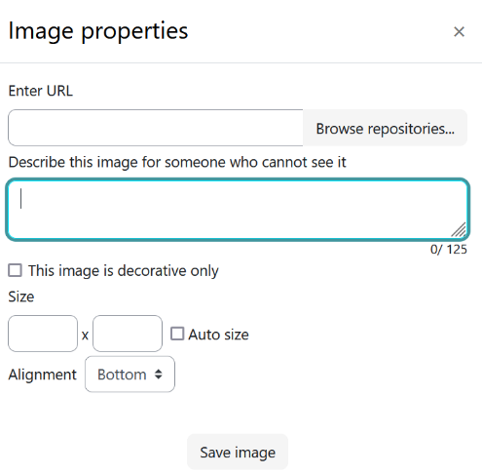Titles – consistent formatting
* Images whithout contained text
* Provide ALT Text!!
* Provide Captions
* 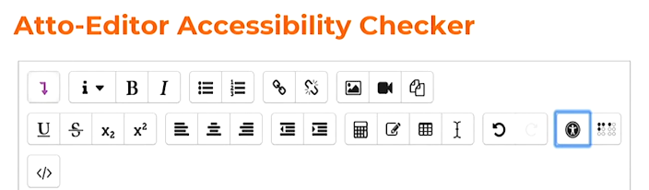Activate Atto-Editor Accessibility checker

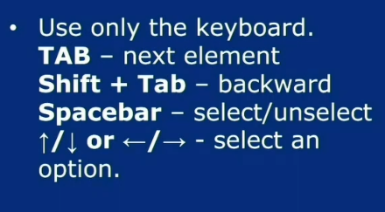

**Quizzes**

* Enable Navigation via keyboard – Have claearly visible Buttons.Try out your Navigation.
* Provide proper Feedback
* Provide enough time – probably no time limit
* 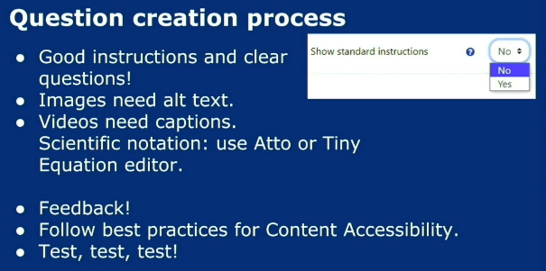Activities/Quiz Types: Drag & Drop is difficult whithout mouse