Help with:

Curriculum creation, quality assurance and course analysis

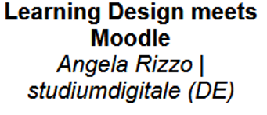

<https://learning-design.eu/en/index>

**Analytics and research teachers!!!**

Fill in a wiki with content. There's a lot to enter to get graphics out

Ease of work

Help teachers plan their teaching.

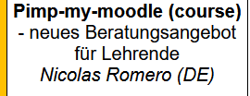

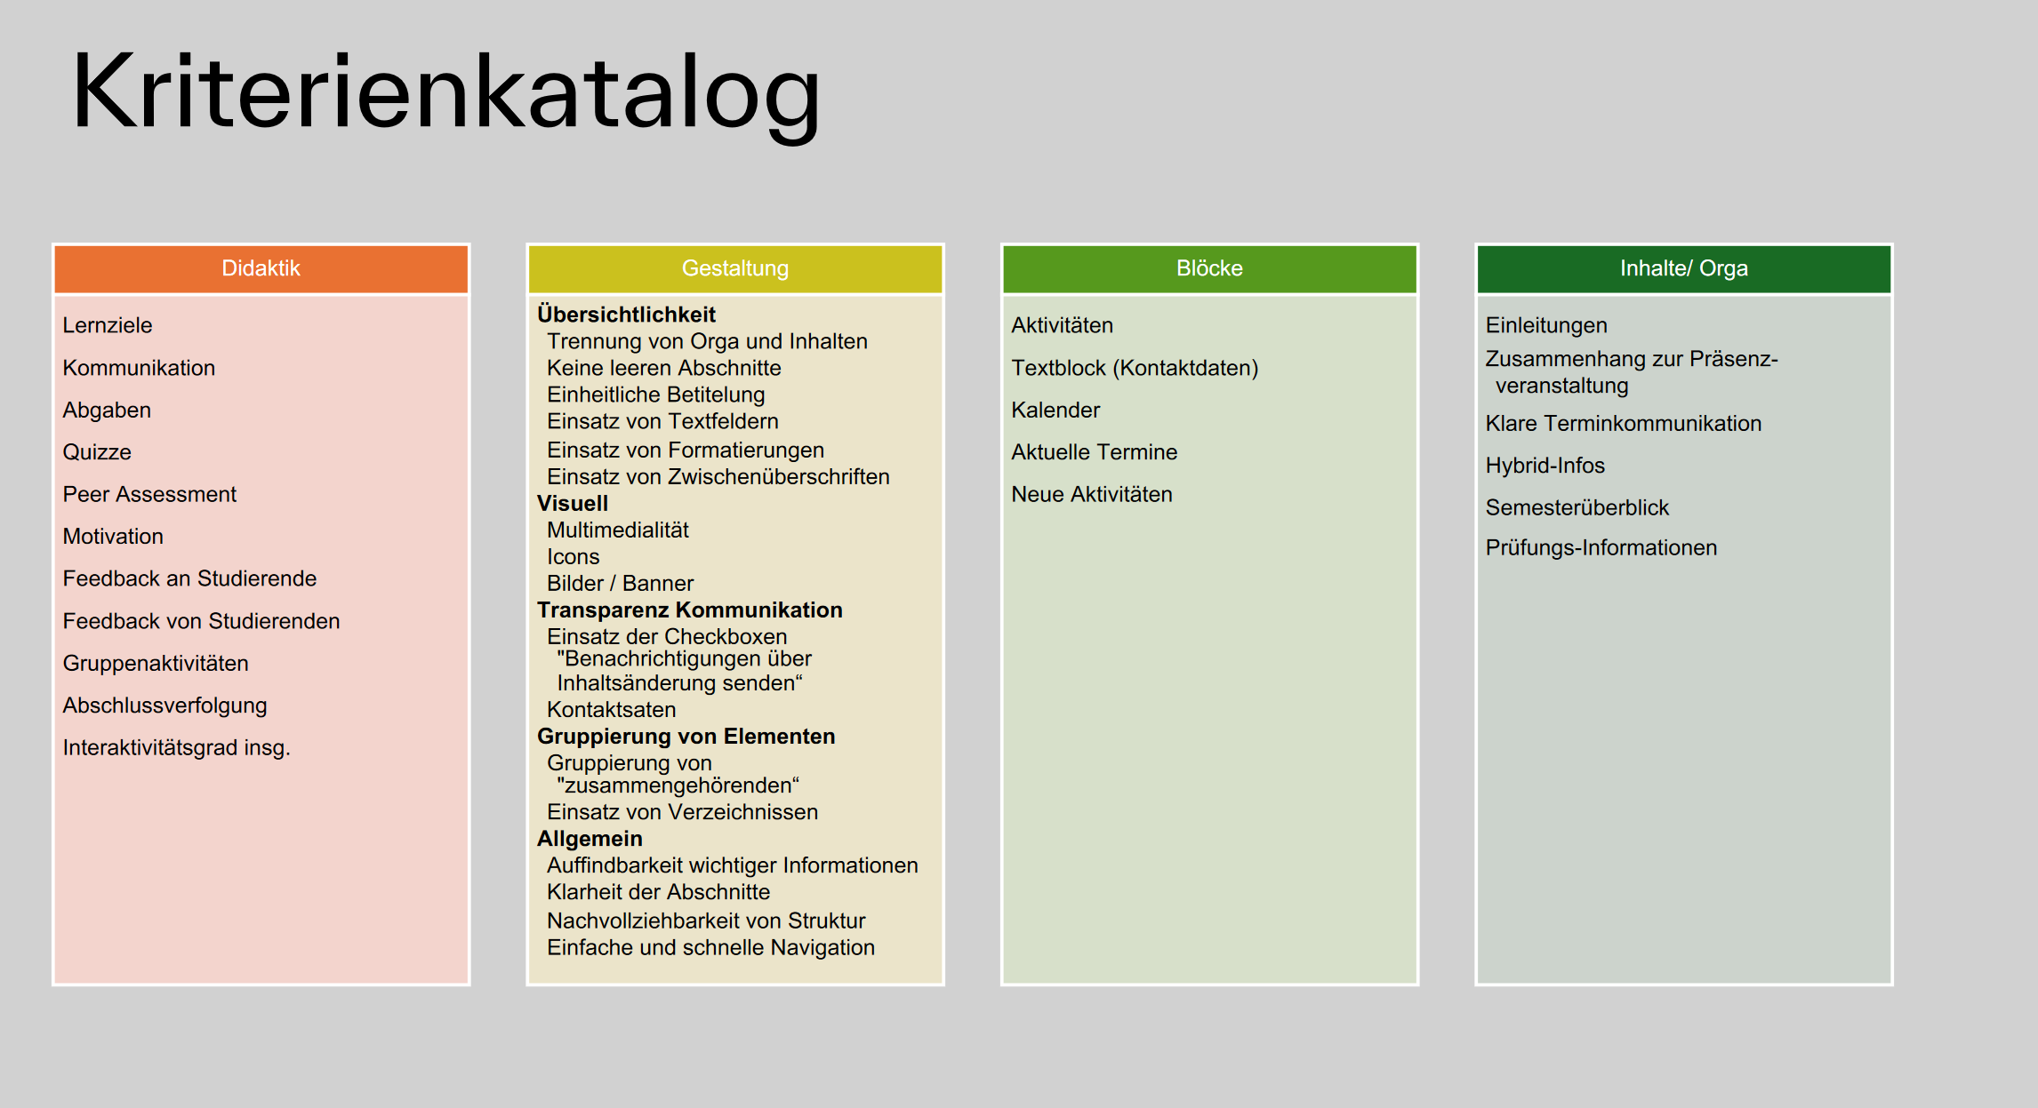

**Presentation slides:** [**https://cloud.hs-augsburg.de/index.php/s/LK2wxcnaJYdtoYT**](https://cloud.hs-augsburg.de/index.php/s/LK2wxcnaJYdtoYT)

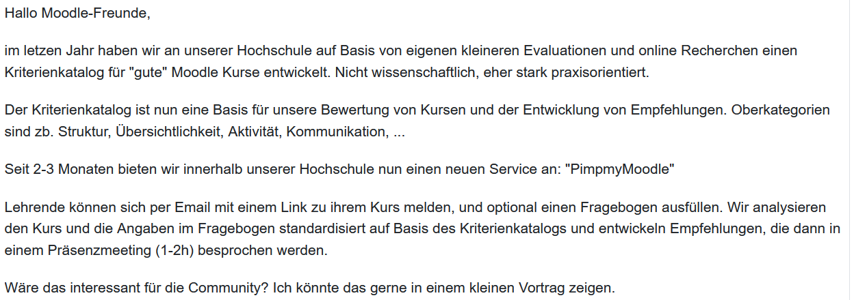

**Quality assurance for moodle courses at mul?**

The recommendations are roughly divided into three areas (sleek course design, clear orientation, attractive layout).

**Incentive systems:**

Certification, Badges. Only if you offer something that will help them.

[Nicolas.romero@tha.de](mailto:Nicolas.romero@tha.de)

<https://Tinyurl.com/pimpmymoodle> <https://www.tha.de/Nicolas-Romero.html>

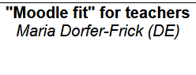**https://moodlemootdach.org/mod/forum/discuss.php?d=6946**

downloads: eLeDia_moodle_4_tool_guide.pdf

Provide lecturers with assistance throughout a few questions for reflection at the end of the semester  
- What function should the eLearning course play in my course?- Was habe ich dafür in dem Kurs bereitgestellt?  
- What was used particularly intensively?  
- What has been used little/hardly/not at all?  
- What have I done to ensure that it is used?  
- What feedback did the students give me??  
- What could I have done differently?  
- How do I adapt the course for the next course?  
- What do I take with me to other courses?

We recently revised the ToolGuide and also printed it as a poster: https://eledia.de/blog/eledia-blog-1/moodle-4-tool-guide-35

We are currently finalizing a planning aid for creating a course. This will end up being a fillable PDF. It guides the lecturer step by step so that he/she gets a plan.

Patrick Thibaudeau presented Cria as an AI-based solution in Moodle at the end of May. Impressive. Here is the recording: <https://moodle.org/mod/forum/discuss.php?d=458899>

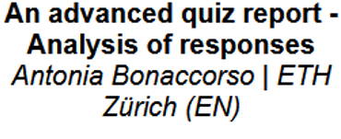

**Quiz reports and analysis**

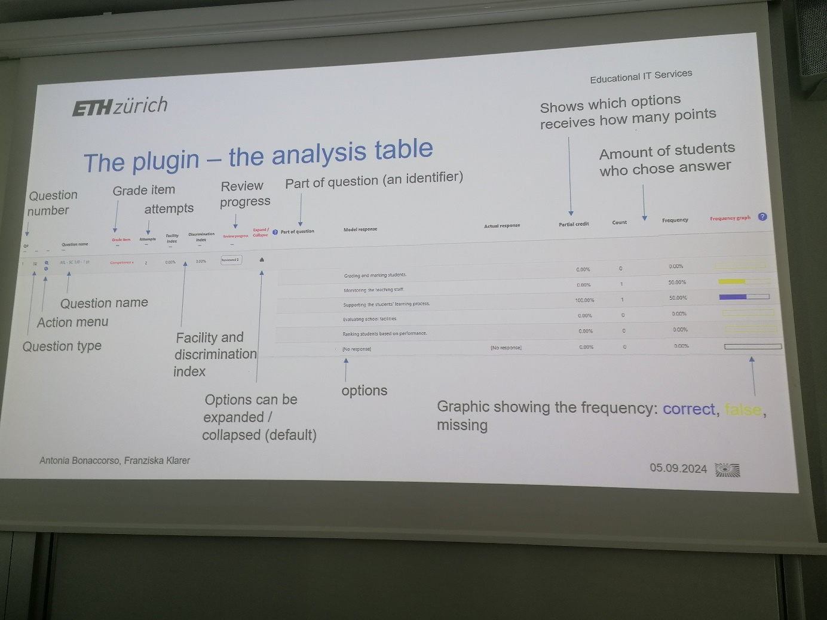

**An advanced quiz report - Analysis of responses***Antonia Bonaccorso | ETH Zürich (EN)*

If you are interested – please get in touch with the CTL.

__________________________________________________________________________

Further tipps:

* Glossaries are helpful, be sure to use them and let students fill them out themselves
* View requirements and progress
* Work with lessons and chapters
* Obtain feedback from students
* Accept and implement quick feedback
* Use H5P
* <https://moodlemootdach.org/mod/forum/discuss.php?d=6951>
* Learning paths help with orientation
* In tile view: display progress as %
* Alternative course format: Tiles, OneTopic (<https://moodle.org/plugins/format_onetopic>)
* Moodle.net
* Urgent questions: Students can create questions themselves and upvote other questions (prioritize)https://moodle.org/plugins/mod_hotquestion
* <https://visual-books.com/moodle-kann-mehr/>