**Title of the abstract (Times Roman 14 pt, bold)**

**A. Author11, B. Author22, C. Author31 (Times Roman 12 pt, bold)**

*1Affiliation University1 (Times New Roman 10pt, italic),*

*2Affiliation University2 (Times New Roman 10pt, italic),*

*e-mail: of communicating author@institution.ac.at*

Leave two blank lines before the text body. Text font: Times New Roman, 12 pt; line spacing: 14 pt, justified; document margins: 2.5 cm top and bottom, 2.5 cm left and right (format A4). The abstract (including figures, see below) must not exceed one page in length. No blank line between paragraphs. New paragraphs are intended (12 mm).

References should be cited in the text as follows: relevant information can be found by Strunz & Nickel (2001), Streckeisen (1967) – alternatively in brackets (Beran et al. 1983) respectively (Zemann, 1948; Jäger, 1962). Leave two blank lines before the reference list but do not give a subtitle to the list. Font size of the reference list: 10 pt, line spacing: 12 pt, justified.

Figures / Tables, should be cited as Fig. 1 / Tab. 1 etc. in the text. Figure / table caption(s) are labelled as Figure 1 / Table 1 etc. and should be placed below the figure / above the table. Font size of the captions: 10 pt, line spacing: 12 pt, justified.

Abstracts should be sent to XX@XX.at (conference e-mail address). Please upload the abstract as a **docx (doc)** file with **embedded** figures and tables (if required).

|  |
| --- |
| Table 1: Minerals crystallising in the zemannite-type structure (font size 10 pt.) |
| Ilirneyite  Mg0.5[ZnMn3+(TeO3)3]∙4.5H2O  Keystoneite  Mg0.5[(Ni, Fe,Mn)2(TeO3)3]∙4.5H2O  Kinichilite  Mg0.5[(Mn2+,Zn)Fe3+(TeO3)3]∙4.5H2O  Zemannite  Mg0.5[ZnFe3+(TeO3)3]∙4.5H2O |

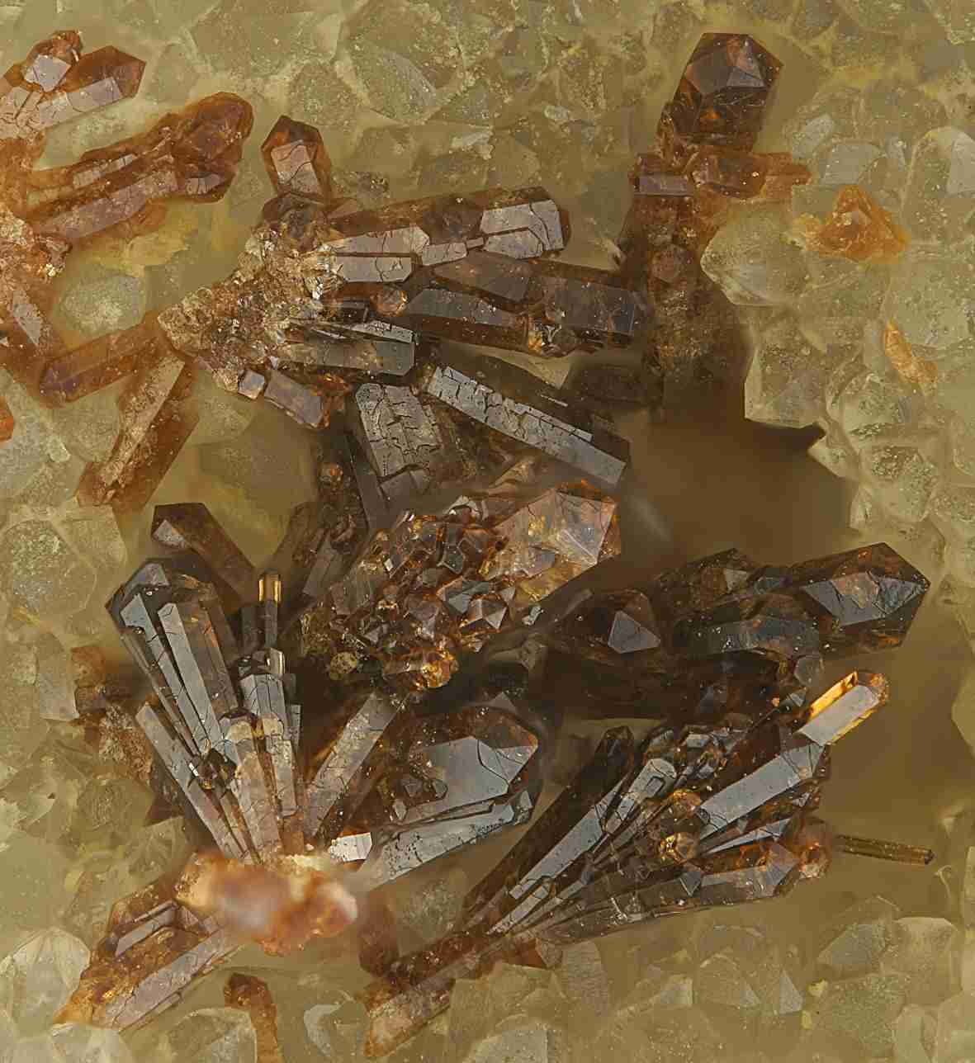

Figure 1: Example of zemannite

Foto: S. Wolfsried (font size 10 pt.)

Beran, A., Hafner, S., Zemann, J. (1983): Untersuchungen über den Einbau von Hydroxylgruppen im Edelstein-Sillimanit. – N Jb Mineral Monatsh, 983, 219-226.

Jäger, E. (1962): Rb-Sr age determinations on micas and total rocks from the Alps. – J Geochem Res, 67, 5293-5306.

Streckeisen, A. (1967): Classification and nomenclature of igneous rocks. – N Jb Mineral Abh, 107, 144-240.

Strunz, H., Nickel, E.H. (2001): Strunz mineralogical tables. – 870p., Schweizerbart, Stuttgart.

Zemann, J. (1948): Formel und Strukturtyp des Pharmakosiderits. – Tschermaks Miner Petrogr Mitt, 1, 1-13.